**Title of Paper (Times New Roman Bold 12 pt)**

First author1, Second author2, Third author3 (Times New Roman 10 pt)

1First author affiliation, University/Institute, City. (Times New Roman 10 pt)

Email: First author Email address

2Second author affiliation, University/Institute, City. (Times New Roman 10 pt)

Email: Second author Email address

3 Third author affiliation, University/Institute, City. (Times New Roman 10 pt)

Email: First author Email address

**Abstract.** Papers dealing with any applications of holography in all branches of science welcome. The abstract should include definition of the problem, assumptions, method of solution, summary of important results. The abstract should clearly state the objective, results and the conclusion of the work. The abstract appears before the keywords.

Keywords: first keyword, second keyword, ... (At least three and maximum five keywords).

**1 Introduction**

These guidelines serve as a template for Microsoft Word. Please carefully follow the instructions provided in this format to ensure legibility and uniformity.

When you open this document, select "Print Layout" from the "View" menu, which allows you to see the two-column format and the footnotes. You may then type over sections by using cut and paste into it, and/or use the markup styles. Please note that your papers should have 4 to 6 pages.

**2 Elements of a Paper**

The basic elements of a paper are listed below in the order in which they should appear:

* Identification number of paper
* The title of paper
* Authors' names and affiliations
* Abstract
* Keywords
* Introduction
* The main body of paper (including figures and tables)
* Results and discussions
* Conclusions
* Acknowledgement (if applicable)
* References
* Appendices (if applicable)

**3 Paper Preparation**

Papers must be prepared in the format of MSWord software, and uploaded from the conference web site (http://www.holography.du.ac.ir) in both PDF and DOC formats.

**Papers may be written in English or Persian, and they will be presented in the language written. However, English papers are preferred.**

The paper size for manuscripts is A4 and it should be written in one column.

For English papers, the fonts for different parts of the paper are in Times New Roman as follows:

* Title: 12 pt bold
* Author(s): 10 pt
* Affiliations: 10 pt
* Keywords: 12 pt
* Section Headings: 12 pt bold
* Subsection Headings: 12 pt
* Body of manuscript: 12 pt
* Caption of tables and figures: 12 pt

The section headings will start from the far left and use spacing between the section headings and the paragraph following it. The first line of the first paragraph of each section is not indented, but the others are indented. Put one space between the texts of main sections. Paper must have page numbers.

**4 Submission of Papers to the Conference Secretariat**

The submitted papers to the conference should be in both the word format and PDF. The only way to send the papers is through the conference web-site. After uploading, a confirmation letter will be sent to the corresponding author.

The papers which are accepted with comments, the authors should modify the paper according to the referees' comments and re-send it back to the conference together with an explanation letter. If papers are not prepared according to the referees and scientific committee comments or this guideline, they will be withdrawn from the conference program.

**5 Footnotes**

Footnotes[1] must be formatted as 10pt Times New Roman and should be numbered consecutively using superscript numbers. The footnotes must be positioned flush left at the bottom of the page in which the first reference appears and must be spaced at one line from the text. This is an example of a footnote.

**6 System of Units**

SI system of units is preferred to be used. If necessary, use the equivalent value in the other system of units in brackets after the SI system of units.

**7 Equations**

Equations should be in text format, not as pictures. Equations should be appeared as the example below. The equation numbers must be bracketed and placed opposite to the equation.

$S=\frac{A}{4}$ (1)

**8 Tables**

Tables must be numbered and the title of the table must be placed on the top of the table with the footnotes on the bottom. Tables must appear where (or as close as to) they are first mentioned in the text. They must be referred in the text as "Table 1".

Table 1. An example of a table.

|  |  |  |  |
| --- | --- | --- | --- |
| Number | Area (m2) |  |  |
| 1 |  |  |  |
| 2 |  |  |  |
| 3 |  |  |  |

**9 Figures and Photographs**

Figures must be numbered and the caption of the figure must come at the bottom of the figure. All the legends and the numerical values on the axes of the curves must be clear and readable. Figures must appear where (or as close as to) they are first mentioned in the text. They must be referred in the text as "Fig. 1". Photographs must be original and are treated similar to figures. Leave one space between the Table/Figure and the text following it.

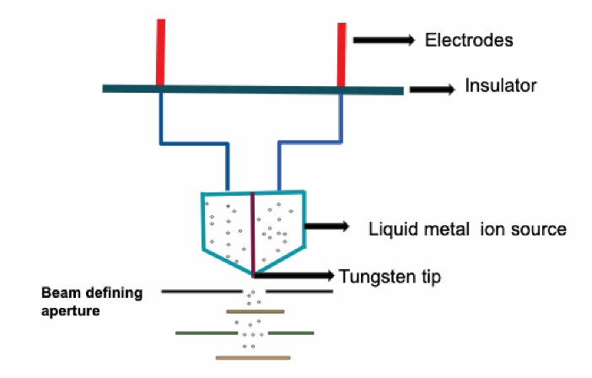

Figure 1. An example of a figure.

**10 Results and Discussion**

Results of the work and discussions are presented here.

**11 Conclusions**

Main conclusions of the paper must be put here.

**Acknowledgement**

Acknowledgements should appear here, if necessary.

**References**

References must be numbered and be listed in the list of references in the order that they are referred to in the text. The reference numbers must be put in the squared bracket for example, [1]. The complete details of the references will appear in the list of references. For journal papers, books and conferences papers use the following formats:

[1] A. Author, B. Author, and C. Author, “Article Title”, Journal Name Vol., page (year).

e.g., Phys. Rev. Lett. 101, 031601 (2008).

[2] A. Author, 1986. Book Name. Publisher Name, Address.

[3] Booklet, A., 1994. Booklet title. On the WWW, at http://www.abc.edu,May. PDF file.

[4] In book, A., ed., 1991. Book title, 1st ed., Vol. 2 of Series Title. Publisher Name, Publisher address, Chap. 1, pp. 1– 3. See also URL http://www.abc.edu.

[5] In collection, A., 1991. “Article title”. In Collection Title, A. Editor, ed., 3rd ed., Vol. 2 of Series title. Publisher Name, Publisher address, May, Chapter 1, pp. 1–3. See also URL http://www.abc.edu.

[6] In proceedings, A., 1991. “Article title”. In Proceedings Title, A. Editor and B. Editor, eds., Vol. 1 of Series name, Organization Name, Publisher Name, pp. 1–3. Paper number 1234.

[7] ASME, 2003. ASME Manual MS-4, An ASME Paper, latest ed. The American Society of Mechanical Engineers, New York. See also URL http://www.asme.org/pubs/MS4.html.

[8] Masters thesis, A., 2003. “Thesis Title”. MS Thesis, University of Higher Education, Cambridge, MA, May. See also URL http://www.abc.edu.

[9] Misc, A., 2003. Miscellaneous Title. On the WWW, May. URL http://www.abc.edu.

[10] PhD thesis, A., 2003. “Thesis Title”. PhD Thesis, University of Higher Education, Cambridge, MA, May. See also URL http://www.abc.edu.

[11] Proceedings, A., ed., 1991. Volume Title, Vol. 1 of Proceedings Series, Organization Name, Publisher Name. See also URL http://www.abc.edu.

[12] Tech report, A., 2003. Tech report title. Progress report 1, University of Higher Education, Cambridge, MA, May. See also URL http://www.abc.edu.

1. An example of a footnote